

Department of Electrical & Computer Engineering

Airborne Sampling/Sensing of Distal Volcanic Ash

Project Group Meeting #14

Minutes

**Minutes of the weekly meeting 03 June 2016**

**Present:**

Maan Alkaisi, Adrian Weller, Jamie Van de Laar, Jake Campbell, Parth Thakur, Ryan Taylor, Mike Shanaher

**1. Apologies:**

* NIL

**2. Minutes from last meeting**

* (look at Minutes, July 8 2016)

**3. Matters arising**

* RFD900+ modem bundle
  + Worth getting
  + Range might not be the one stated on the brochure.
  + Take design and power into consideration.
  + Bandwidth issue in NZ. Check if the bandwidth can be adjusted.
  + Be vary of the components placement as it can induce noise.
* Plane Interior (Fig 1.)
  + Ask NIWA if they are happy for the team to change the plane interior
  + Inner will be modularised so changes can be made easily.
  + Center of gravity has to be carefully monitored.
* Wind Tunnel (Fig 2.)
  + DTA can send down a controller to help with the running of the fan.
  + Could use other battery types.
  + Connect the fans independently.

**4. Correspondence**

* NIL

**5. Progress Reports:**

* Jamie Van de Laar
  + Interfacing Raspberry pi & OPC sensor
  + Done python scripting.
  + Done manual connection between the two.
  + Needs to create a automatic data transfer system through I2C.
  + Test the whole system in the test chamber with the bulk ash provided
* Jake Campbell
  + Looked at modularising each sensor.
    1. This is so any necessary changes can be easily made to the plane.
  + OPC sensor has to be parallel to wind flow
    1. Sensor needs to be vertically mounted.
    2. A hose needs to be connected from the bottom of the plane to the OPC for wind flow.
* Mike Shanaher
  + See file “Hardware Layout”.
  + Blue- Standard hardware.
  + Grey- Motor, RC controller.
  + Green- Modules added to the system.
  + Have an SD card to store data in case radio is not operational.
  + Could log sensor data separately into Raspberry Pi.
* Ryan Taylor
  + Made tunnel section.
  + Buy Perspex to add to the wind tunnel.
  + Look into the insertion of ash into the wind tunnel. It is recommended that ash be put after the honeycomb mesh.
  + Measure air speed while conduction tests.

6. **Other business:**

**Meeting ACTION LIST**

|  |  |  |
| --- | --- | --- |
| **ACTION** | **ASSIGNED TO** | **DUE DATE** |
|  |  |  |
|  |  |  |
|  |  |  |

**Next meeting date: Friday 22 July 1030hrs**

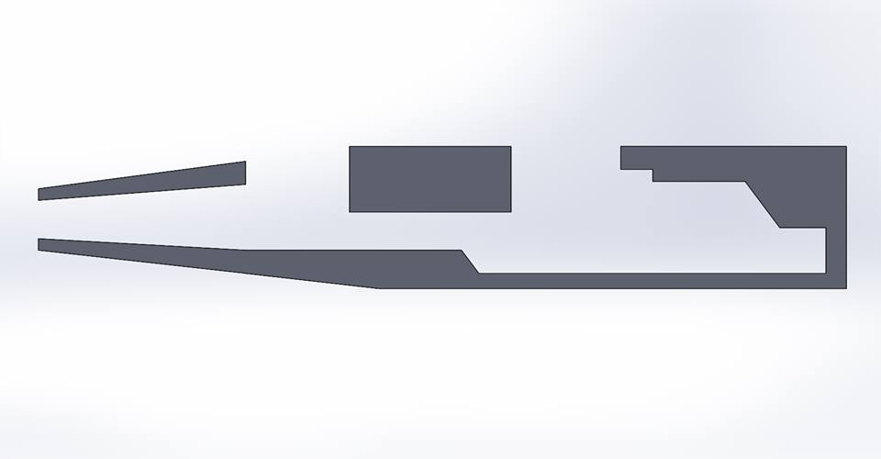

Figure 1. Plane interior

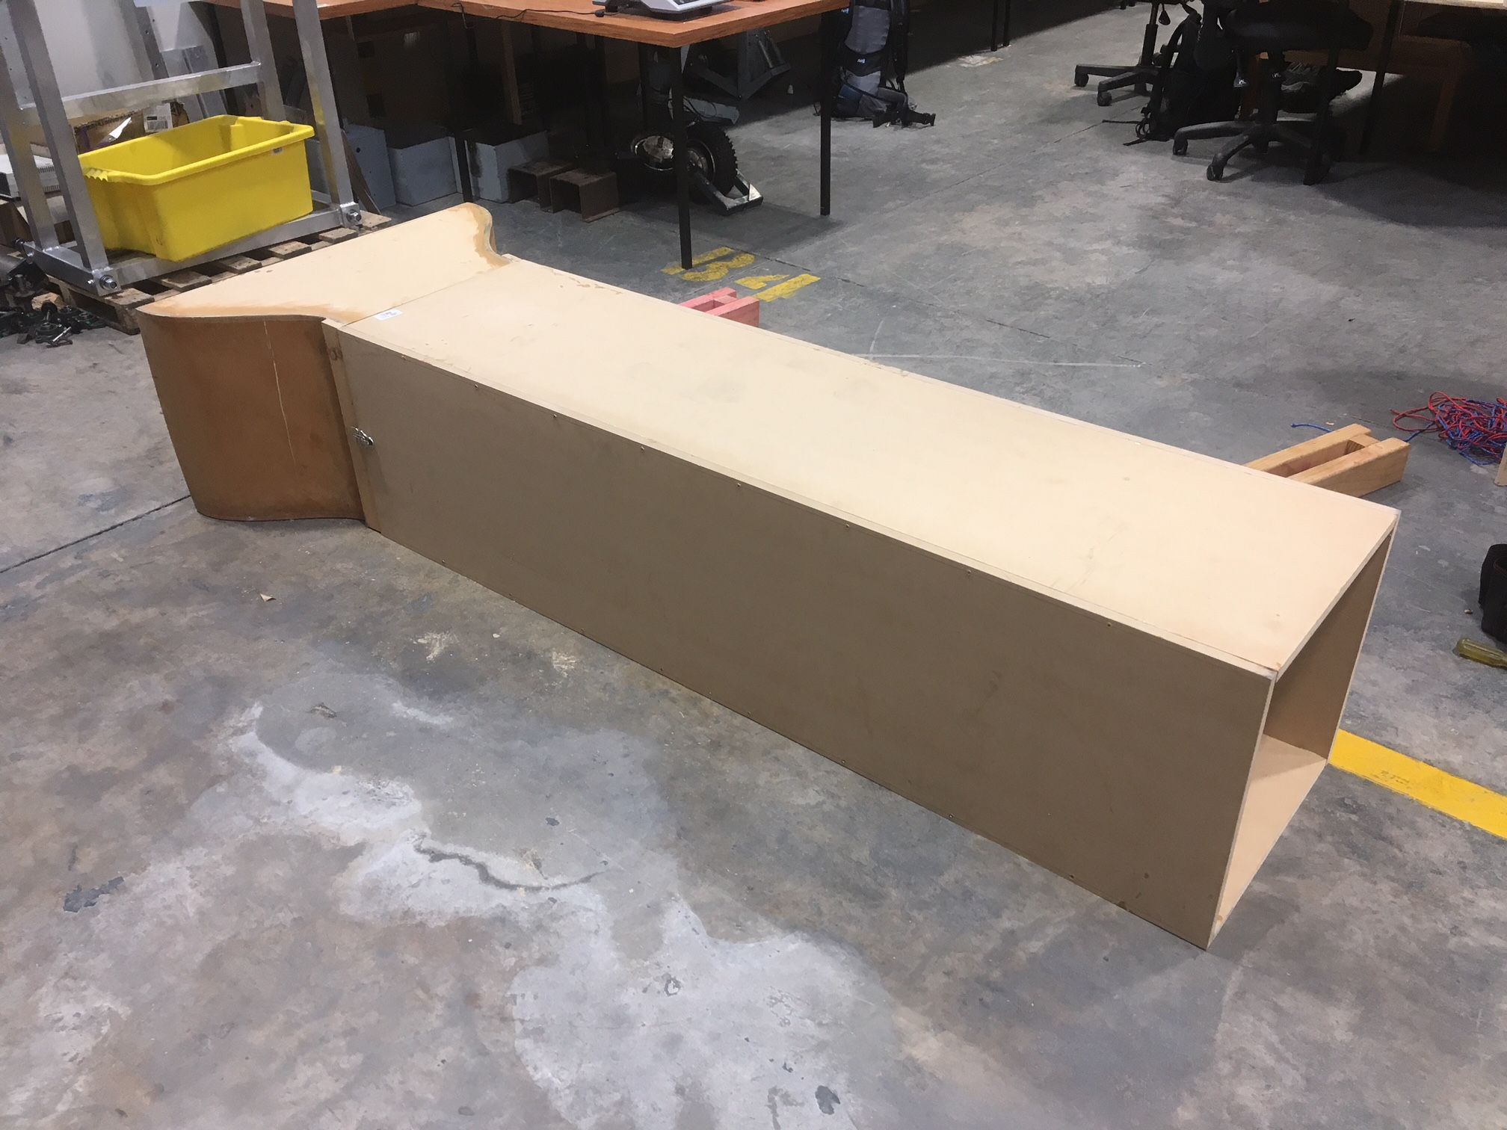

Figure 2. Wind Tunnel